 | United Way Attendance Matters  Meeting 9/29/24
Synergy Attendance Reports
ATD401 / ATD402
- Date range
- Continuous absences (ATD402)
- If using for period attendance, set All Day Code in Mass Change Attendance Definition
- Runs at district or school level
- Includes student name, grade level, contact information
- Output to Excel to further refine or summarize
Synergy Admin Report (SQL Query)
Student Total Absence
- Absence percent for each student
- Date range
- Filters for absence percent, grade level, homeroom
- Output to Excel to further refine or summarize
Synergy Query (Pull of Raw Data to Use in Excel)
Daily Attendance Detail
Period Attendance Detail
Synergy Attendance Letter
- Define how Synergy calculates an absence by percentage, database value, etc.
- Create letters and/or email messages to print/send based on number of absences
- Letters can attach to PVUE Documents and require acknowledgement
- Reports run in high detail mode contain additional information

- Attendance Definition – set district level definition(s)
- Mail Merge Letter – set district or school level letter(s)
- Email & Message Content – set district level email content
- Attendance Letter – set school level using above

Resources:
Edupoint Mail Merge 2.0 Guide
Edupoint Attendance Administrator Guide
- Attendance Definition – Page 144
- Attendance Letter – Page 130
Edupoint ETN-SIS-2025_622700_Attendance_Letters_V2-Ability_To_Email_Letters_To_Parents.pdf

ETC Full Support Clients – Call ETC
Edupoint Clients – Call Edupoint

Examples:
Mass Change Attendance Definition “Set All Day Code”
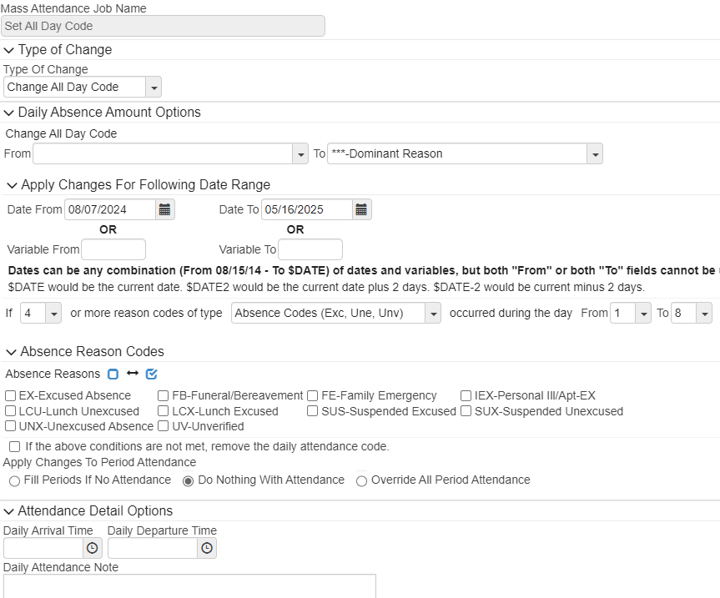

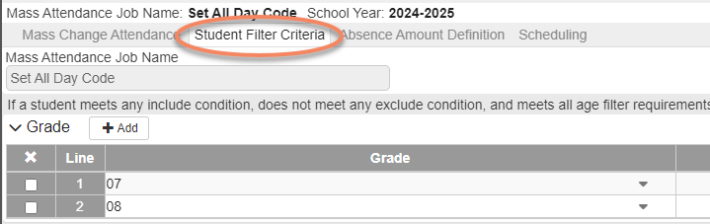

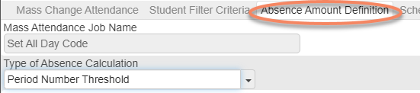

Examples:
Attendance Definition
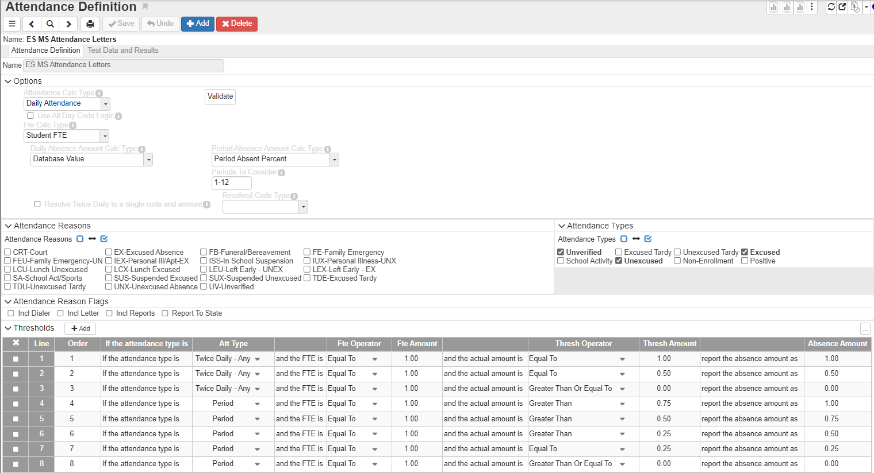

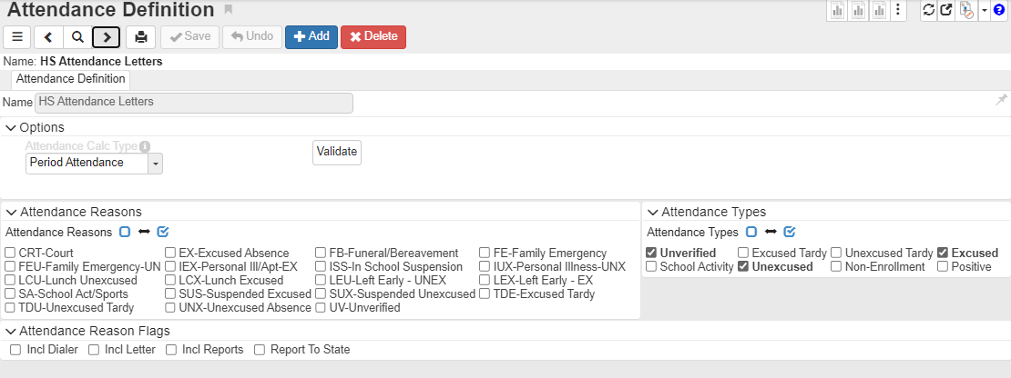

Examples:
Mass Change Attendance Definition “Set All Day Code”
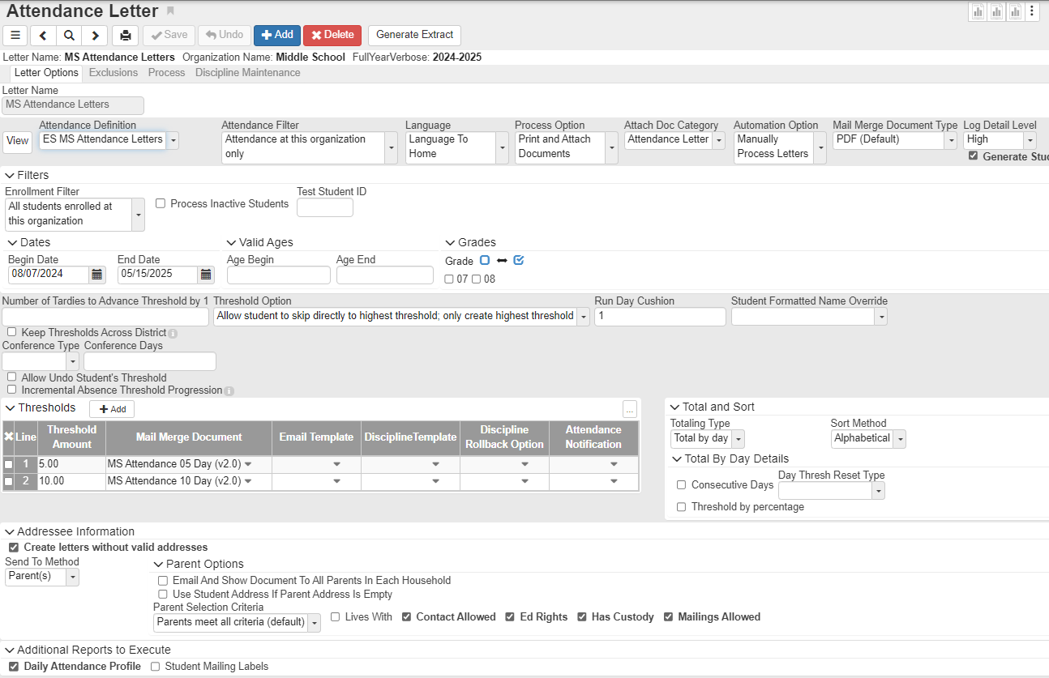

Query Text
Daily Attendance Detail
Student R0, K12.EnrollmentInfo.StudentSchoolYear R1, K12.EnrollmentInfo.StudentEnrollment R2, Revelation.OrganizationInfo.RevOrganizationYear R17 (OrganizationYearGU,R1.OrganizationYearGU,Outer), K12.AttendanceInfo.StudentDailyAttendance R3, K12.AttendanceInfo.Setup.SchoolAttendanceReasons R12 (CodeAbsReasSchYearGU,R3.CodeAbsReas2GU,Outer), K12.AttendanceInfo.Setup.SchoolAttendanceReasons R15 (CodeAbsReasSchYearGU,R3.CodeAbsReas1GU,Outer), K12.AttendanceInfo.Setup.DistrictAttendanceReasons R14 (CodeAbsReasGU,R12.CodeAbsReasGU,Outer), K12.AttendanceInfo.Setup.DistrictAttendanceReasons R16 (CodeAbsReasGU,R15.CodeAbsReasGU,Outer), Revelation.OrganizationInfo.RevOrganization R18 (OrganizationGU,R17.OrganizationGU,Outer), Revelation.OrganizationInfo.RevYear R19 (YearGU,R17.YearGU,Outer)
COLS R0.FormattedName (1.5in,'Student Name',,PageBreak,Group1), R0.SisNumber (.75,'School ID',,,Group1), R0.EdfiID (.75,'State ID',,,Group1), R1.Grade (0.5in,,,,Group1), R18.OrganizationName (2.5,'School',,,Group1), R3.AbsDate (.7,'Date'), R3.AbsFte1 (0.6in,'AM',,,,,,Code), R16.Type (.6,,,,,,,Code), R16.Abbreviation (.6,'Code'), R3.AbsFte2 (0.6in,'PM',,,,,,Code), R14.Type (.6,,,,,,,Code), R14.Abbreviation (.6,'Code'), R3.Note (3), R3.ArrivalTime (.7,'Arrival'), R3.DepartTime (.7,'Departure')
If R3.AbsDate Not =
Sort R0.FormattedName, R3.AbsDate

Period Attendance Detail
Student R0, K12.EnrollmentInfo.StudentSchoolYear R1, K12.EnrollmentInfo.StudentEnrollment R2, Revelation.OrganizationInfo.RevOrganizationYear R7 (OrganizationYearGU,R1.OrganizationYearGU,Outer), K12.AttendanceInfo.StudentDailyAttendance R3, K12.AttendanceInfo.StudentAttendancePeriod R4, K12.AttendanceInfo.Setup.SchoolAttendanceReasons R5 (CodeAbsReasSchYearGU,R4.CodeAbsReasGU,Outer), K12.AttendanceInfo.Setup.DistrictAttendanceReasons R6 (CodeAbsReasGU,R5.CodeAbsReasGU,Outer), Revelation.OrganizationInfo.RevOrganization R8 (OrganizationGU,R7.OrganizationGU,Outer), Revelation.OrganizationInfo.RevYear R9 (YearGU,R7.YearGU,Outer)
COLS R0.FormattedName (1.5in,'Student Name',,PageBreak,Group1), R0.SisNumber (0.75in,'School ID',,,Group1), R0.EdfiID (0.75in,'State ID',,,Group1), R1.Grade (0.5in,,,,Group1), R8.OrganizationName (2.5in,'School',,,Group1), R3.AbsDate (0.7in,'Date'), R4.BellPeriod (0.5in,'Prd'), R6.Type (0.5in,,,,,,,Code), R6.Abbreviation (0.5in,'Code',,,,,,Code), R3.Note (3in,'Note Daily'), R4.Note (2.5in,'Note Period'), R4.ArrivalTime (0.7in,'Arrival'), R4.DepartTime (0.7in,'Departure')
If R3.AbsDate Not =
Sort R0.FormattedName, R3.AbsDate, R4.BellPeriod

Synergy Admin Report (SQL) “Student Total Absence”
s.LAST_NAME [Last Name]
, s.FIRST_NAME [First Name]
, s.SIS_NUMBER [Perm ID]
, s.GRADE_LEVEL [Grade]
, s.GENDER_DESC [Gender]
, s.RESOLVED_ETHNICITY_RACE_DESC [Resolved Race/Ethnicity]
, s.ENTER_DATE [Enter Date]
, te.TOT_ENRLL [Total Days Enrolled]
, ISNULL(att.TOT_ABS,'0.00') [Total ABS]
, ISNULL(cast(cast(cast(att.TOT_ABS as decimal(18,2))/cast(te.TOT_ENRLL as decimal (18,2))*100 as decimal(18,2)) as varchar(6)),'0')+ ' %' as [ABS Percent]
, s.ORGANIZATION_NAME [Current School]

from dbo.vETC_Student s
left join ( select

satt.STUDENT_GU
, YEAR
, sum(CAST(abs_amount as decimal(3,2))) TOT_ABS

from rev.EPC_EDFI_STU_SCH_ATT satt
join dbo.vETC_Student s on satt.STUDENT_GU = s.STUDENT_GU
and s.ORGANIZATION_YEAR_GU = @ORGANIZATION_YEAR_GU

where EVENT_DATE between @FROM_DATE and @TO_DATE

group by satt.STUDENT_GU, YEAR
) att on s.STUDENT_GU = att.STUDENT_GU
and (s.SCHOOL_YEAR + 1) = att.YEAR
left join (select
s.STUDENT_GU
, s.ORGANIZATION_YEAR_GU
, count(sc.DATE) TOT_ENRLL
from dbo.vETC_Student s
join dbo.vETC_School_Calendar_Dates sc on s.ORGANIZATION_YEAR_GU = sc.ORG_YEAR_GU
and (s.TRACK_GU is null or s.TRACK_GU = sc.TRACK_GU)
and sc.IN_SESSION = 'Y'
and sc.DATE between @FROM_DATE and @TO_DATE

group by STUDENT_GU, ORGANIZATION_YEAR_GU
) te on s.STUDENT_GU = te.STUDENT_GU
and s.ORGANIZATION_YEAR_GU = te.ORGANIZATION_YEAR_GU

where s.ORGANIZATION_YEAR_GU = @ORGANIZATION_YEAR_GU
and s.ACTIVE_STATUS_RECORD = 1
and s.LEAVE_DATE_RAW is null

Order by s.LAST_NAME, s.FIRST_NAME

-----
select
DATE as FROM_DATE
, DATE as TO_DATE
from dbo.vETC_School_Calendar_Dates
where ORG_YEAR_GU = @ORGANIZATION_YEAR_GU
and IN_SESSION = 'Y'

